. 1. Identify and complete the following tables.

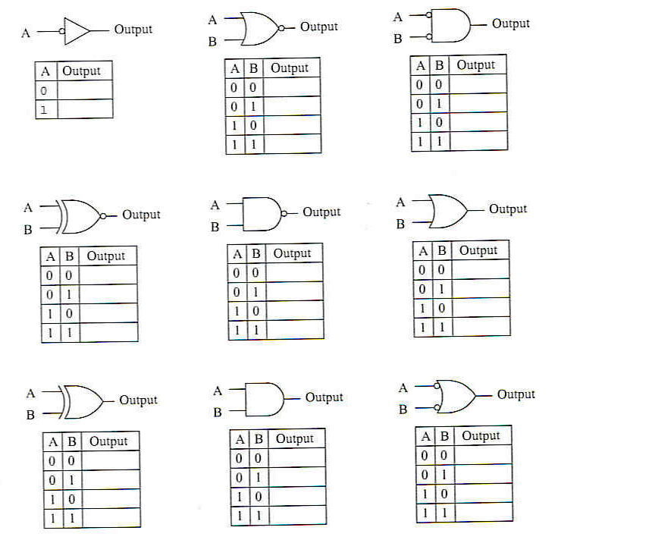

2. In your own words, what does a Pull-Up or Pull-Down resistor do?

3. Determine the logic levels at each of the test points, transistor and LED on or off when the switch is closed.
V_{TP1} = _________, V_{TP2} = ________, V_{TP3} = _______, V_{TP4} =_____,
Transistor = ____________, LED = ____________.

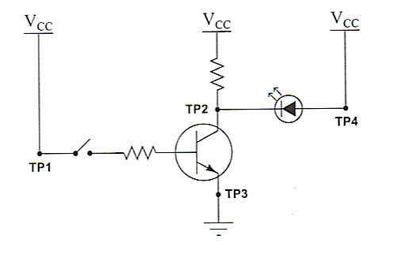

- What is the advantage(s) of the TTL gates equipped with totem-pole output circuitry?

5. Draw the paths of all currents in this circuit with the input in a “low” state. Indicates which transistors are on or off?

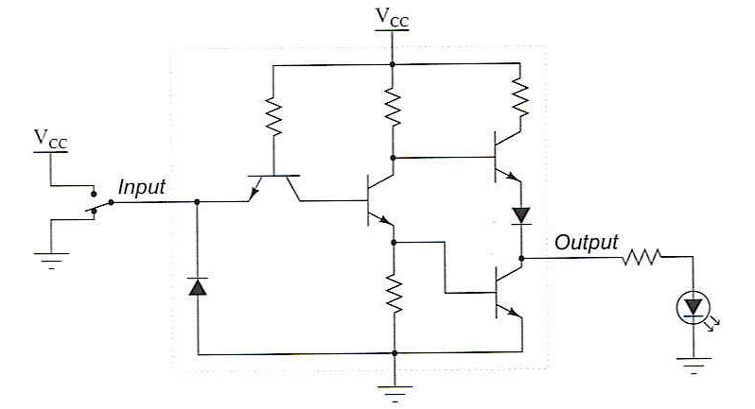

6. Complete the following table and identify which transistor is on or off? (Example: ‘0’ = logical low, and ‘1’ = logical high of a TTL circuit).
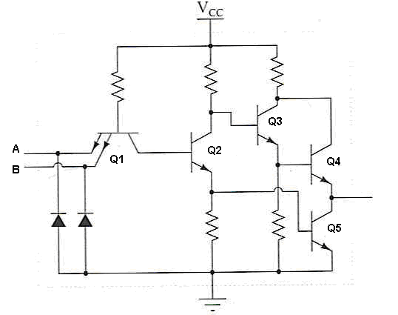

A | B | Q1 | Q2 | Q3 | Q4 | Q5 | Output
0 | 0
1 | 1

- What is the difference between a Totem-pole output vs the Open-Collector Output?

- Complete the following table and identify which CMOS devices are on or off.(example: ‘0’ = logical low and ‘1’ = logical high of a TTL circuit ?)

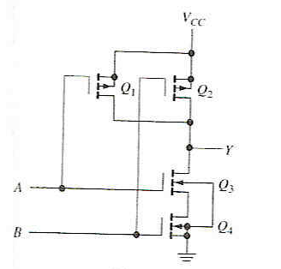

A | B | Q1 | Q2 | Q3 | Q4 | Y
0 | 0
0 | 1
1 | 0
1 | 1

- Complete the following table and identify which CMOS devices are on or off.(example: ‘0’ = logical low and ‘1’ = logical high of a TTL circuit ?)

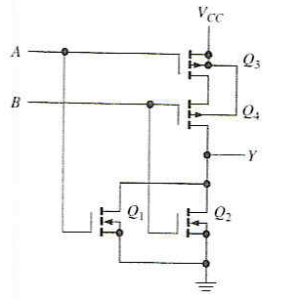

A | B | Q1 | Q2 | Q3 | Q4 | Y
0 | 0
0 | 1
1 | 0
1 | 1

- Write a truth table for this circuit and identity its function.
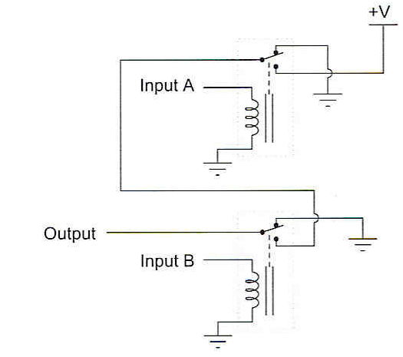

A | B | Output
0 | 0
0 | 1
1 | 0
1 | 1

- Write a truth table for this circuit and identity its function.
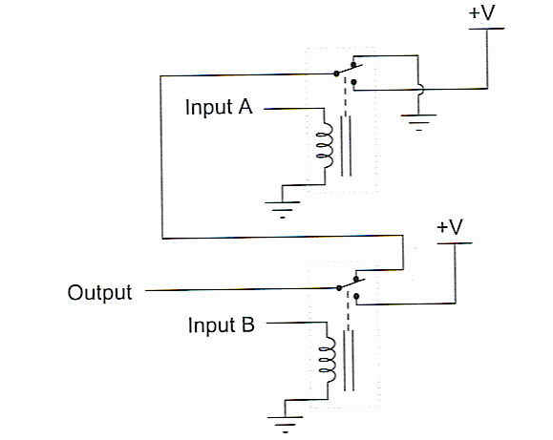

A | B | Output
0 | 0
0 | 1
1 | 0
1 | 1

- Identify and complete the following tables:

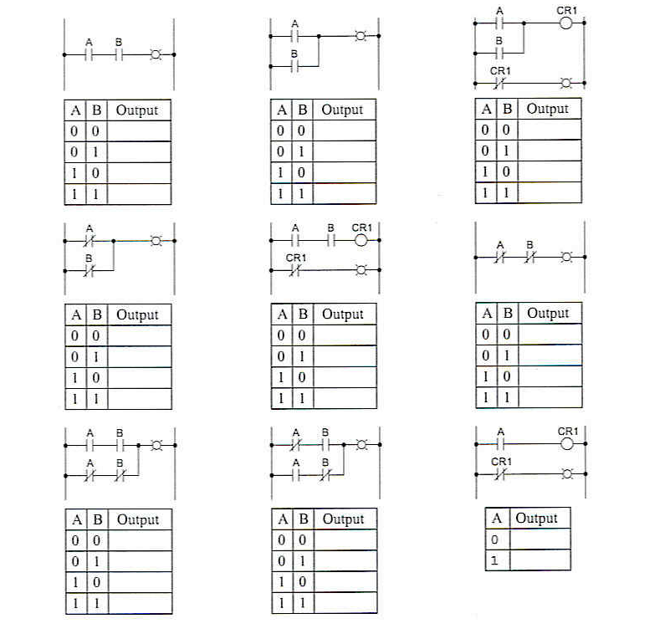

- In your own words, explain:
  - Fan-out
  - Noise Margin
  - Propagation Delay.
  - Rise Time
  - Bus contention
  - Buffer
  - Sink Current
  - Source Current

- Analyze the following relay logic circuit, completing the truth table accordingly:

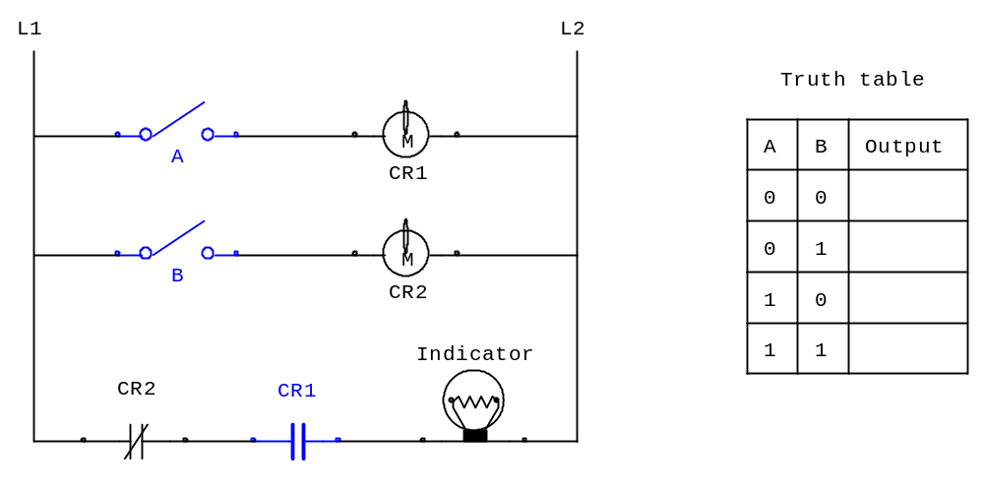

- How to resolve the HIGH-level input problem, between a TTL to CMOS gate

- How to resolve the current issue between a CMOS to TTL devices..

- Analyze the following relay logic circuit, completing the truth table accordingly

